PROJECT REPORT

*on*

STOCK PRICE PREDICTOR

(CSE VI Semester Mini project)

(2022-2023)

Guided by:             Submitted by:

Dr. Santosh Kumar                            Abhiney Kumar

              Roll No: 2014519

     Sec-A

Class Roll-02

**Acknowledgement**

*Here by I am submitting the project report on* ***“Stocks Price Prediction”*** *as per the scheme of Graphic Era Deemed to be University, Dehradun for VI semester mini project submission.*

*In this connection, I would like to express our deep sense of gratitude to my beloved institution Graphic Era Deemed to be University and also I like to express my sincere gratitude and indebtedness to Dr Santosh Kumar****.***

*I consider it my cardinal duty to express the deepest sense of gratitude to* ***Mr. Santosh Kumar****, for the invaluable guidance extended at every stage and in every possible way.*

*Finally, I am very much thankful to all the faculty members of the Department of Computer Science and Application, friends and our parents for their constant encouragement, support and help throughout the period of project conduction.*

~ABHINEY KUMAR

**TABLE OF CONTENTS**

1. **INTRODUCTION**
   1. About project
   2. Objectives
   3. Problems
   4. scope
2. **PROJECT**
   1. Algorithm used
   2. Methodology
   3. results
3. **CONCLUSION**
4. **REFRENCES**

INTRODUCTION

**what is a stock?**

A stock (also known as an equity) is **a security that represents the ownership of a fraction of a corporation**. This entitles the owner of the stock to a proportion of the corporation's assets and profits equal to how much stock they own. Units of stock are called "shares."

**can we apply machine learning to stocks?**

Stock Price Prediction [using machine learning](https://www.projectpro.io/article/top-10-machine-learning-projects-for-beginners-in-2021/397) is the process of predicting the future value of a stock traded on a stock exchange for reaping profits. With multiple factors involved in predicting stock prices, it is challenging to predict stock prices with high accuracy, and this is where machine learning plays a vital role.

Investment firms, hedge funds and even individuals have been using financial models to better understand market behavior and make profitable investments and trades. A wealth of information is available in the form of historical stock prices and company performance data, suitable for machine learning algorithms to process.

Can we actually predict stock prices with machine learning? Investors make educated guesses by analyzing data. They'll read the news, study the company history, industry trends and other lots of data points that go into making a prediction. The prevailing theories is that stock prices are totally random and unpredictable but that raises the question why top firms like Morgan Stanley and Citigroup hire quantitative analysts to build predictive models. We have this idea of a trading floor being filled with adrenaline infuse men with loose ties running around yelling something into a phone but these days they're more likely to see rows of machine learning experts quietly sitting in front of computer screens. In fact about 70% of all orders on Wall Street are now placed by software, we're now living in the age of the algorithm.

**Objective**

To create a machine learning model which predicts the future stocks price.

Stock Price as a Time Series Data

Treating stock data as [time-series](https://www.projectpro.io/article/time-series-projects/444), one can use past stock prices (and other parameters) to predict the stock prices for the next day or week. Machine learning models such as Recurrent Neural Networks (RNNs) or LSTMs are popular models applied to predicting time series data such as weather forecasting, election results, house prices, and, of course, stock prices.

Here, we will be using LSTM for our model

Understanding Long Short Term Memory Network for Stock Price Prediction

LSTM is a Recurrent [Neural Network](https://www.projectpro.io/article/neural-network-projects/440) that works on data sequences, learning to retain only relevant information from a time window. New information the network learns is added to a “memory” that gets updated with each timestep based on how significant the new sample seems to the model. Over the years, LSTM has revolutionized speech and handwriting recognition, language understanding, forecasting, and several other applications that have become the new normal today.

A standard LSTM cell comprises of three gates: the input, output, and forget gate. These gates learn their weights and determine how much of the current data sample should be remembered and how much of the past learned content should be forgotten. This simple structure is an improvement over the previous and similar RNN model.

Methodology followed

1. Gathering data and libraries

Data is gathered using tiingo API and libraries imported are:

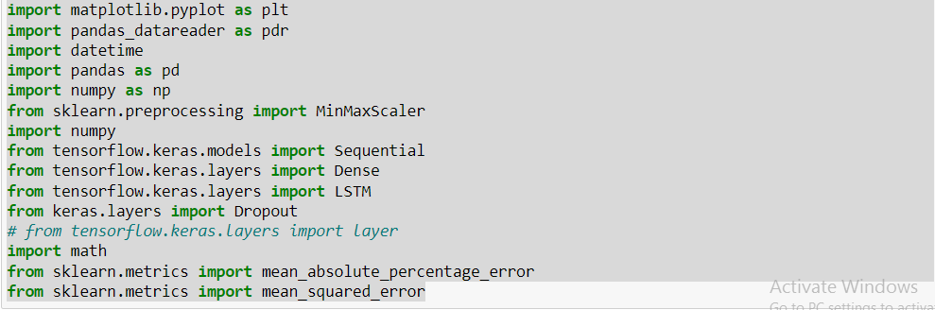

2. Data Set Visualization  
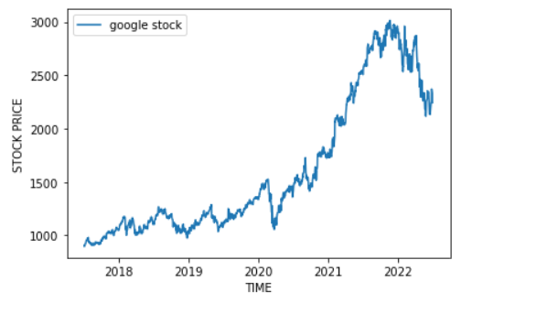

Visualizing data as training and testing data  
 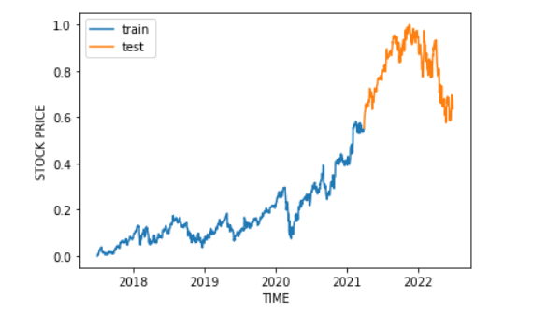

3.Building Lstm Model

Here we will be using single LSTM layer  
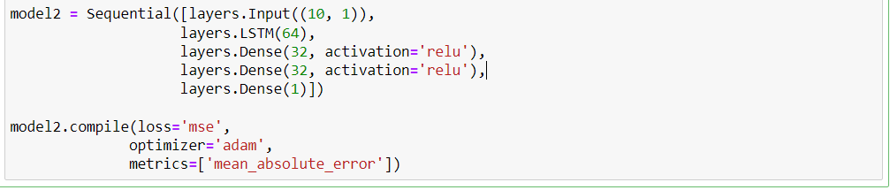

After building we fitted the data on the LSTM.

4.Visualizing losses

5.Results on training data

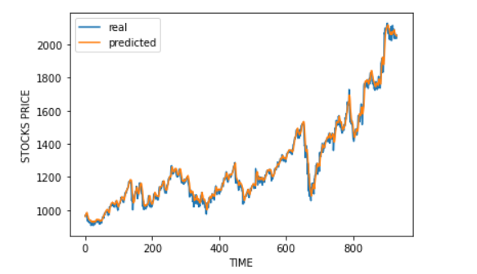

Results on testing data

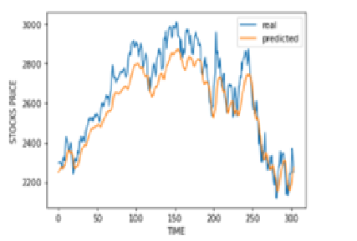

6.Errors

mean square error = 93.7532355025297

root mean squared error = 9.682625444709183

Mean Absolute Percentage Error= 0.02951306812189307

**Conclusion**

LSTMs seem to be the best initial approach in solving the stock price prediction problem. Other methods can combine features extracted from LSTM or Bi-LSTM models and fed into a classical ANN regressor. This approach might help extract information previously missed by a simple LSTM regression model. More [recent research](https://aclanthology.org/2020.emnlp-main.676.pdf) uses graph neural networks and multi-headed attention mechanisms, while others use reinforcement learning. [LSTM-based approaches](https://arxiv.org/pdf/2004.10178v2.pdf) are also being actively used and researched lately despite such complex mechanisms being proposed regularly—Head over to [Stock Market Prediction | Papers](https://paperswithcode.com/task/stock-market-prediction) With Code to see the latest work in this domain.

**Reference**

[www.google.com](http://www.google.com)

[www.github.com](http://www.github.com)

[www.stackoverflow.com](http://www.stackoverflow.com)

[www.edureka.com](http://www.edureka.com)

[www.anaconda.com](http://www.anaconda.com)

[www.tiingo.com](http://www.tiingo.com)

[www.youtube.com](http://www.youtube.com)